**Task - 1**

**Name :** Sujithra M

Email ID : [sujiedusport@gmail.com](mailto:sujiedusport@gmail.com)

**Task Title**: Responsive Hospital Management Web Page

**Task Description**: The second task involves developing a responsive Landing Page using HTML and CSS. I created a Hospital Management Web Page. The web page includes details about the hospital, registration, List of doctors working in the hospital, facilities and services provided in the hospital,. The primary goal is to utilize HTML and CSS to create the web page and make the website responsive across various devices. This project aims to showcase coding skills, creativity, and attention to detail in implementing the design reference effectively.

**Steps Taken:**

1. **HTML Structure:** Created the HTML structure ensuring semantic markup and accessibility standards. Used Various HTML tags to develop the layout of each element on a web page.

2. **CSS Styling:** Utilized CSS to style the HTML elements according to the design specifications including fonts, colors , backgrounds , spacing, pointer, border alignment.

3. **Responsive Design:** Implemented media queries and flexible layout techniques to ensure responsiveness across various devices and screen sizes.

**Challenges Faced:**

**Responsive Layout:** Adapting the design to ensure responsiveness across different devices posed a challenge, especially in handling complex layouts and interactions.

**Solutions Implemented:**

Media Queries and Flexbox Layout Module played a major role to make the web page responsive.

**1.Media Queries:** Implemented media queries to adjust layout and styling based on screen size, ensuring optimal display across devices.

**2.Flexbox Layout Module**: Implemented Flexbox Layout Module for arranging items in rows or columns. Flexbox offers space distribution between items and powerful alignment capabilities.

**Learnings:**

1. **HTML Structure:** Learned various HTML tag and its properties.
2. **CSS Techniques:** Learned advanced CSS techniques such as

* **Flexbox Layout Module**: Used Flexbox to streamline page structure and enhance responsiveness.
* **Grid Layout Module**: Also used Flexbox to streamline page structure and enhance responsiveness.
* **Media Queries:** Gained a deeper understanding of responsive design principles and techniques for creating adaptable layouts using Media Queries.
* **Transition:** Used Transition to change property values smoothly over a given duration

**Project Update:**

The responsive Hospital Management Web Page has been successfully developed. The web page is developed with Markup language called Hyper Test Markup Language(HTML) and Style sheet language called Cascading Style Sheets(CSS). The page is fully functional and responsive, showcasing the information effectively across various devices and screen sizes.

**Project Images:**

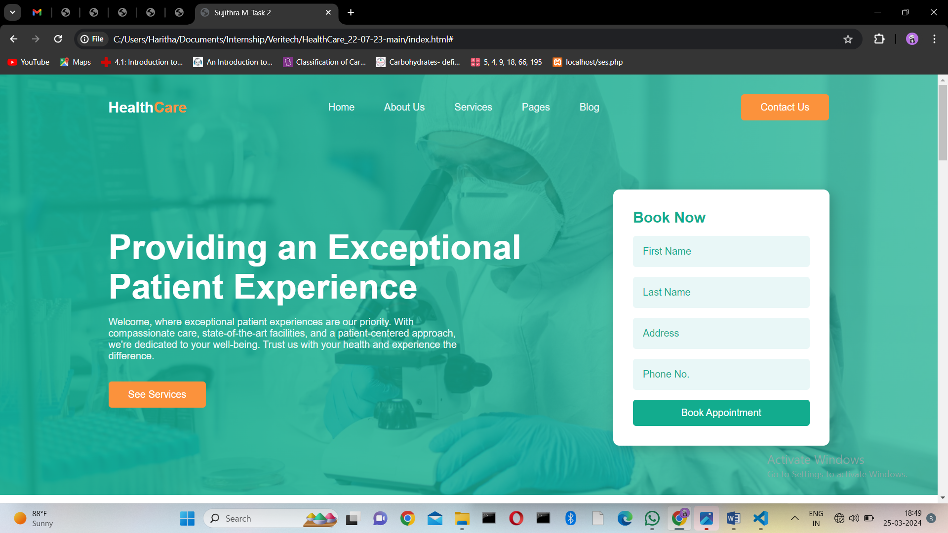

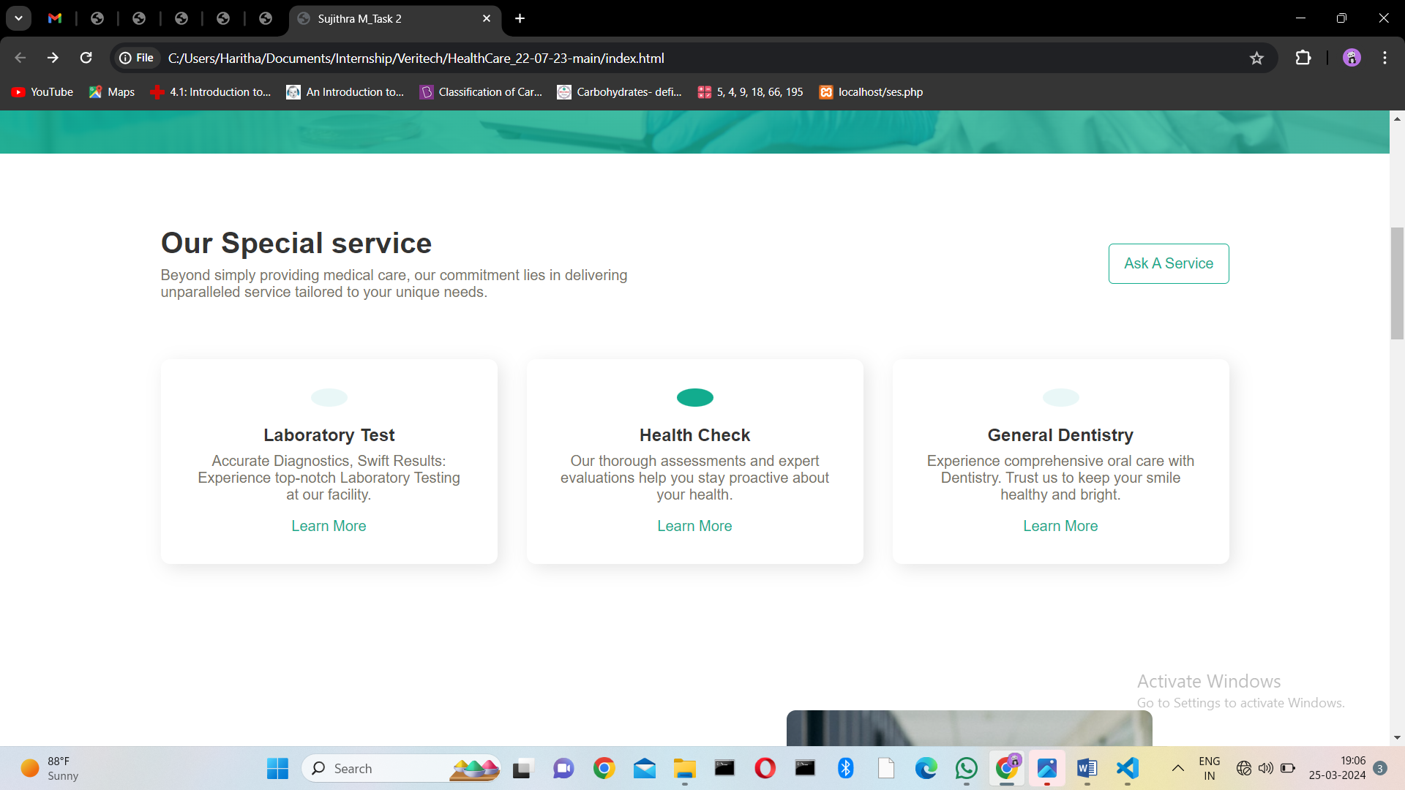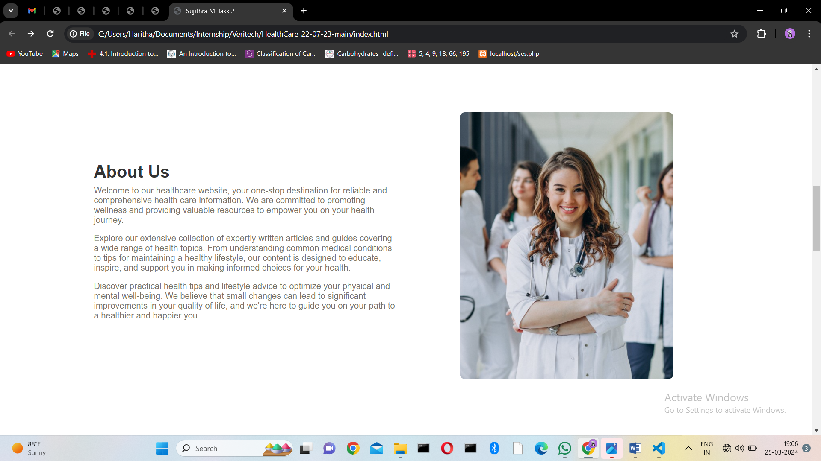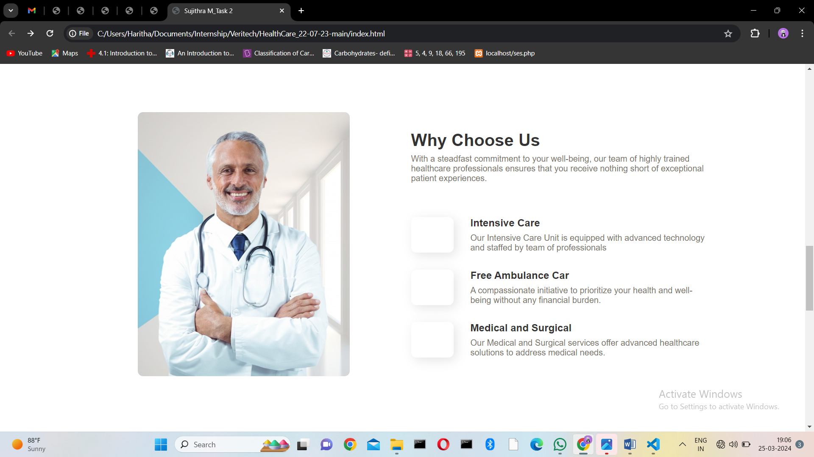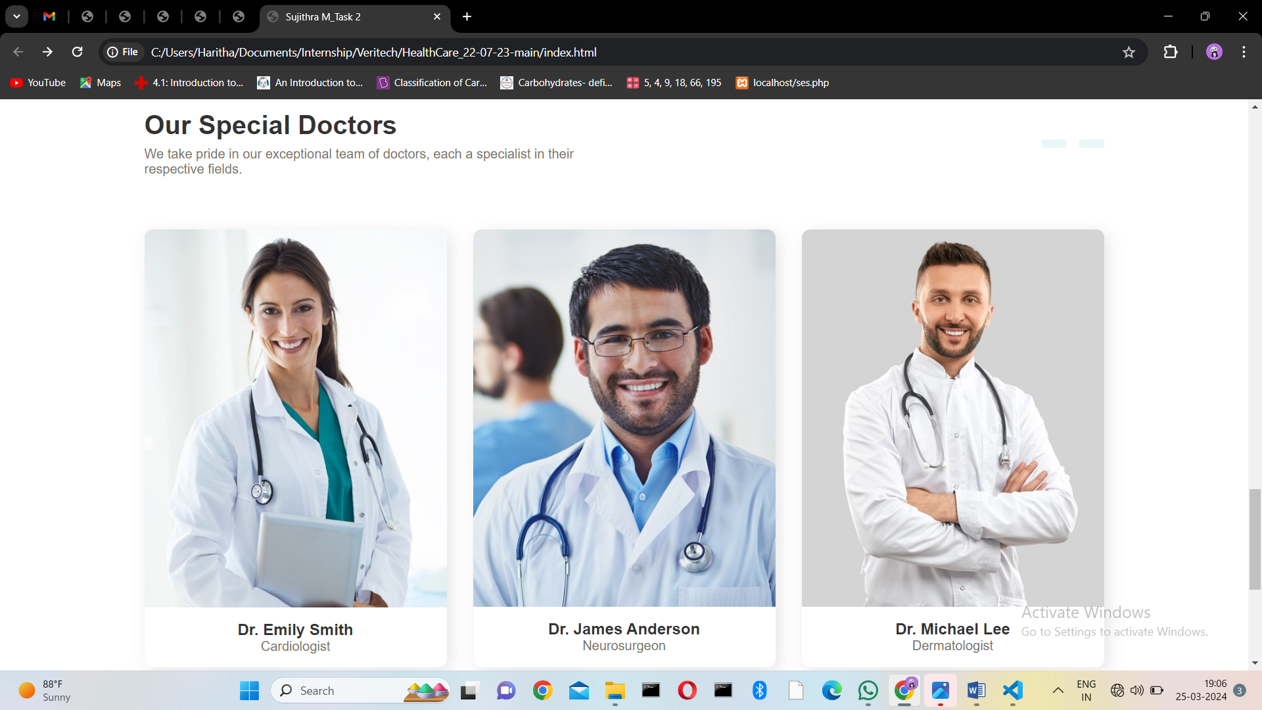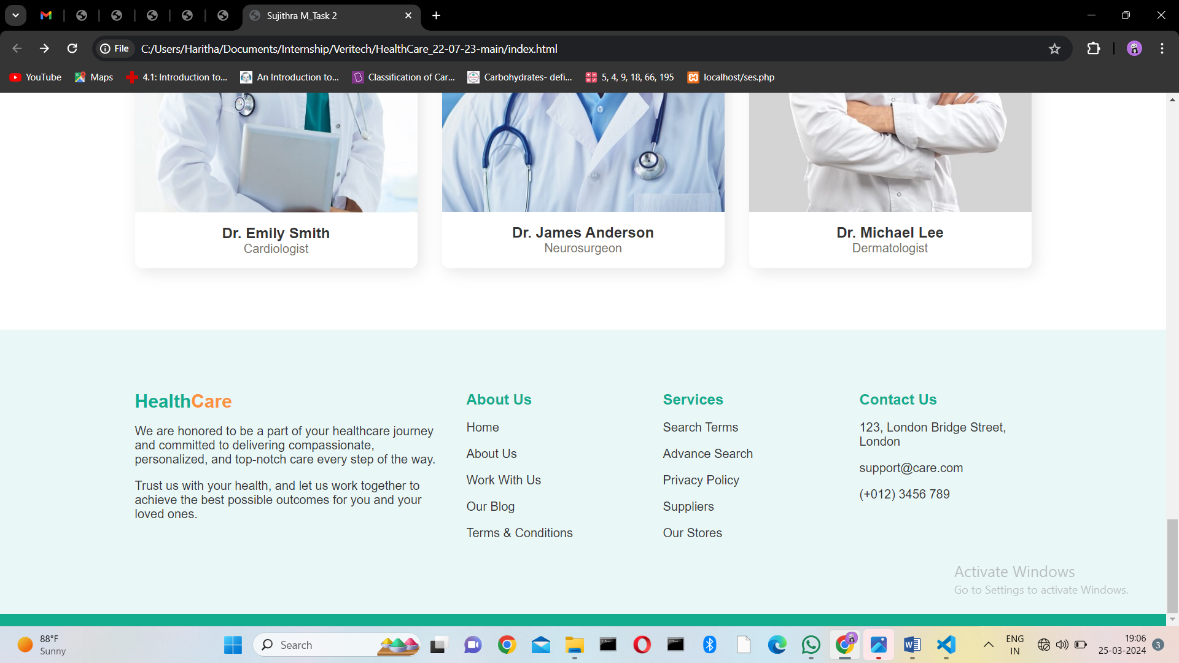

**Date: 25-03-2024**